
British International School
Primary School
Lesson Plan

Class: Year 3  Subject: Science |  | Date: Week 2 (Apr 27- May 1)  Lesson One |  |  | Teacher’s name:
Learning outcomes:  - To describe reflectors of light |  |  |  |  |  | Assessment:  classwork  Do page 110 and 111
Topic: Light |  |  | Evaluation
Success Criteria | - To understand the sources of light  - To identify objects that reflect light
Starter:
Ask students questions on the topic they learned in the previous lesson.
- Who can tell us some examples of sources of light?
Introduction:
The teacher will introduce the daily lesson by writing the topic on the white board and students will be asked questions based on the topic.
- Have you ever looked in a mirror? What do you see?
- Do mirrors make their own light, or do they show light from somewhere else?
Development:
The daily lesson will be presented to the students by using flash card and video. Students will be given time to do group work and an individual activity on the reflectors of light.
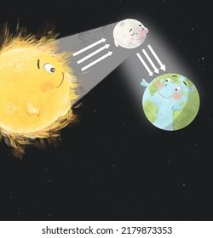
The moon reflecting the sun’s light

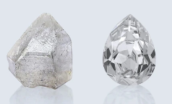
Uncut and cut Diamond

Reflecting Light
- Some objects make their own light—these are called sources of light. Examples: The Sun, A candle, Fireworks
- Some objects do not make their own light, but they can reflect light from another source. Examples:
  - The Moon looks bright, but it does not make light—it reflects the Sun’s light.
  - Diamonds can reflect light, but how well they do this depends on their shape. Uncut diamonds are rough and do not reflect much light. Cut diamonds are shaped in a special way to reflect a lot of light, making them shine brightly. This is why jewelers cut diamonds into different shapes to make them sparkle!
  - A mirror is a smooth and shiny surface that reflects light. Reflection happens when light bounces off a surface. That’s why we can see ourselves in a mirror. Mirrors are one of the best reflectors because they have a very smooth surface.
  - A mirror ball, also called a disco ball, is covered with many tiny mirrors. It does not make its own light but reflects light from another source, like a spotlight or lamp.
  - Water does not make its own light; it only reflects light from other sources, like the Sun or lamps.
  - Water can reflect light, just like a mirror, but its reflection depends on how smooth the surface is. If the water is still, the reflection is clear. If the water is moving, the reflection looks wavy or broken. At night, water can reflect city lights or the Moon’s light, making it look shiny and bright.

Guided Practice:
Students will form groups and sort out different objects (Sun, Moon, mirror, diamond, etc.) as either a light source or reflectors of light.
Plenary:
The day’s lesson will be revised by asking students to come in front of the class and tell in their own words what they learned about reflectors of light. If there are students who are having difficulty, they will be differentiated, and extra help will be given.
Planning for SEN: -
Differentiation ;
-For students who need extra support, provide additional visuals and one-on-one assistance.
- Challenge advanced students by giving them extra worksheets.
Resource:  - Pictures of reflectors of light  - Educational videos on reflectors of light  - Supplementary book |  |  |  | Homework:  Any unfinished work will be given as homework

